**Access permissions in Microsoft 365 eDiscovery**

To access the features available within Microsoft eDiscovery a user needs appropriate permissions. These permissions can be assigned by the Compliance Administrator or the Global Administrator on the [Security and Compliance center](https://docs.microsoft.com/en-us/microsoft-365/compliance/microsoft-365-compliance-center).

Apart from the Compliance Administrator and the Global Administrator, users in the eDiscovery Manager and eDiscovery Administrator role group can perform eDiscovery related tasks.

eDiscovery manager and eDiscovery administrator are sub-groups that fall under the eDiscovery manager compliance center role. Users can be added to these sub-groups by navigating to the eDiscovery manager group under the *Permissions* page.

**eDiscovery Manager:**An eDiscovery manager can only manage the case that they create. They can create and manage Core and Advanced eDiscovery cases, create case holds, run searches, preview, and export search results, add and remove members, and access case data.

**eDiscovery Administrator:**An eDiscovery administrator can perform all the tasks that the eDiscovery manager can. Additionally, an eDiscovery administrator can access all the Core and Advanced eDiscovery cases listed in the compliance center.

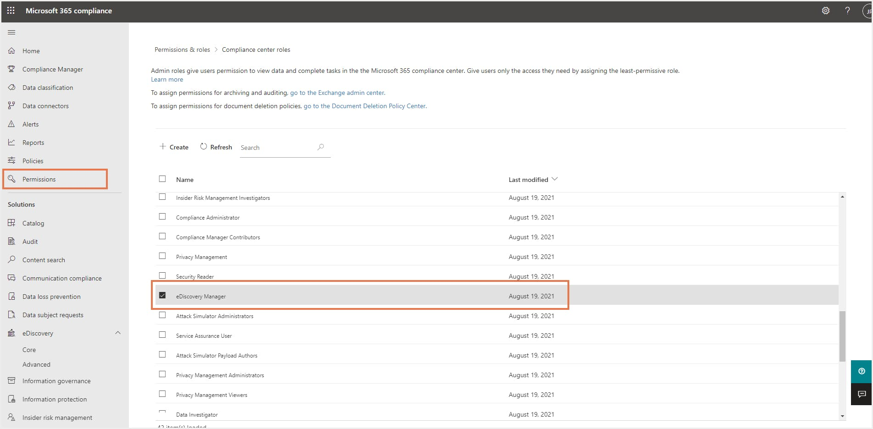

The sub-groups can then be edited individually to add users to either of the roles by navigating to Compliance Center> Permissions> eDiscovery Manager> Edit role group.

